AGENTICA 2.0: Project Overview, Problem, and Core Capabilities

Project Title: ChatBot — Text & Voice Agents
Team Name: ELITE

i.Problem Statement:
Current digital systems are characterized by complex menus and deep hierarchies, leading to significant pain points:
- Cognitive Load: Users expend excessive mental effort on learning and recalling navigation steps.
- Accessibility Barriers: Users needing voice interaction (e.g., visual impairment, hands-free environment) are underserved.
- Lack of Natural Flow: Interactions are transactional and rigid, lacking the context retention and fluidity of human dialogue.
Proposed Solution and Core Capabilities:
The system is an AI conversational interface designed to dismantle traditional interface barriers and allow users to complete tasks via natural dialogue.
- Dual Input: Accepts text and voice queries.
- Intelligent Understanding: Uses AI for intent recognition, entity extraction, and context maintenance.
- System Abstraction: Simplifies complex system interaction by handling underlying navigation and task execution via natural language.
Elite-Nexus-AI Implementation Overview:
The technical framework, Elite-Nexus-AI, is an AI-powered fully automated AI assistant model with low-latency, privacy-first conversational agent built on a Dockerized backend that orchestrates Speech-to-Text (STT), Large Language Model (LLM) processing (using Ollama and Gemini), and high-fidelity Text-to-Speech (TTS). Specially integrated LLMs for image generation, code generation. This system includes a unique feature: live webcam integration that allows it to accept input via sign language. This provides results based on the signs, making the application extremely beneficial for people with disabilities.

Core Capabilities for Workflow Automation:
- Multimodal Input: Supports text and voice commands, leveraging context from local data and live applications.
- Agentic, Autonomous Execution: Uses an Agentic Workflow to break down goals into sub-tasks for autonomous execution, securely integrating with Google Workspace (e.g., Calendar, Gmail) and external APIs.
- Real-time Multilingual Support: Provides instant, seamless input/output translation for global accessibility.
- High-Fidelity Voice: Utilizes ElevenLabs integration for human-like, nuanced vocal responses.
Key Innovation: Behavioral Moderation System (BMS)
- The Boundary Management System (BMS) is placed between Natural Language Understanding (NLU) and Dialogue Management for safe, ethical, and productive interactions. Its primary functions include safety screening, compliance checking, input filtering (e.g., blocking abuse), boundary enforcement (refusing out-of-scope actions), and contextual vetting. The BMS enhances user trust and protects system integrity by proactively monitoring and regulating exchanges.
II. Technical Architecture and System Workflow:

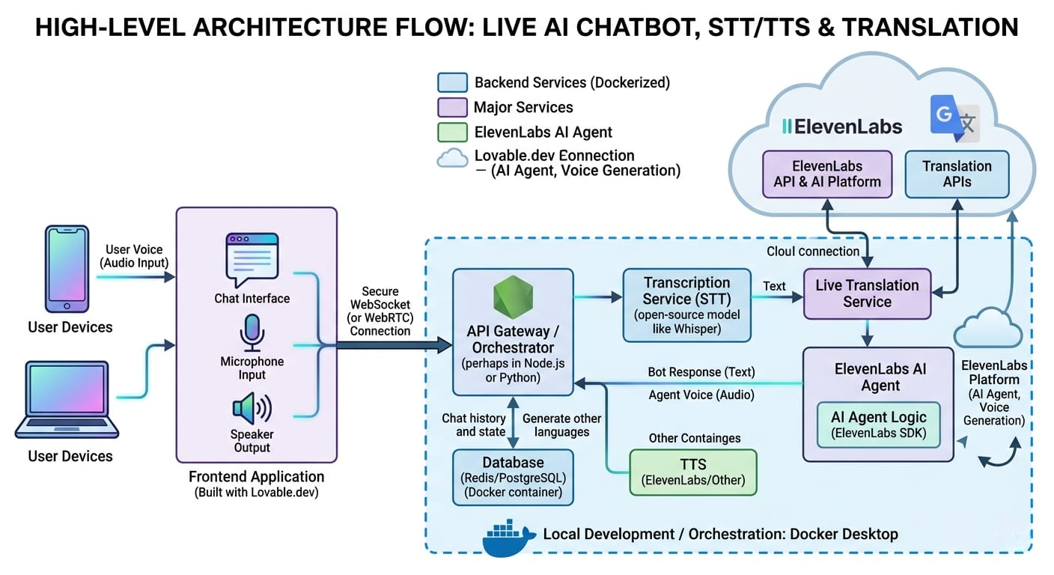

System Workflow: 7-Step Request Processing Flow:
The ChatBot system follows a clear, linear workflow:
- Input Reception: Text or voice input (via STT) is received.
- Speech Processing (STT): Converts speech to text.
- Natural Language Understanding (NLU): Identifies Intent and extracts Entities.
- Behavioral Moderation System (BMS): Screens intent and text for compliance/safety.
- Dialogue Management: Determines the next step (follow-up or task execution via application interface).
- Response Generation: Formulates the final text.
- Output Delivery: Displays Text Output or synthesizes Voice Output (TTS).
Technical Architecture: The Orchestration Layer, the system's central "Brain," is hosted in scalable, portable Docker Desktop containers.

A. Frontend Layer (User Interaction Hub):
The Lovable.dev application manages microphone/speaker functionality with noise suppression. It uses a persistent, bi-directional WebSocket connection for real-time text and control signal transmission to the backend, enabling a "Live" conversation and displaying transcriptions, agent actions, and visual data.

B. Orchestration Layer Components:
- API Gateway/Orchestrator: Built with Node.js or Python, this is the data entry point. It handles routing and manages chat state using Redis (in-memory) for active history and PostgreSQL for archiving.
- Transcription (STT): A dedicated service converting audio to text, primarily using self-hosted, private Local Whisper Models (e.g., CTranslate2) for speed, with commercial APIs as backup.
- Live Translation: (Optional) Translates transcribed text into the agent's working language before it reaches the Action Layer.
- Action Layer (LLM & Tools): The intelligence core. It uses the Gemini LLM for intent recognition and executes tasks via Tool/Function Calling to real-world APIs like Google Calendar, Gmail, and Slack.
III. Implementation Steps and Advanced Capabilities:
Phase 1: Environment Setup & Core Containerization
Set up a reproducible environment by installing Docker Desktop and containerizing core services: Orchestrator, PostgreSQL, Whisper (STT), and Local LLM (Ollama) with models like Llama 3/Mistral for private processing. Securely configure the ElevenLabs API key via environment variables for TTS.
Phase 2: Real-Time Integration & Action Pipeline
- Transcription: Audio streams via WebSocket to the STT service (Whisper), which sends transcribed text to the Orchestrator.
- Decision: Orchestrator sends the prompt and context to the Ollama service. The LLM returns a "Function Call" (for action) or a "Message" (direct response).
- Action & Summary: If a "Function Call" is received, the Orchestrator executes the action via Google Workspace or External API. The result is sent back to Ollama for the local LLM to synthesize a natural final summary text.
- Output: The final text is sent to the ElevenLabs API for high-fidelity TTS and immediately streamed back to the frontend via WebSocket for a real-time conversational experience.
Advanced Elite-Nexus-AI (v2.0) Enhancements:
The system is now a multimodal, polyglot AI workstation.
- Expanded Model Hub: Integrates specialized "Expert" LLMs:
  - Elite-Code Engine: For generating/debugging code (CodeLlama/StarCoder).
  - Nexus-Vision: For image generation (Stable Diffusion/DALL-E).
  - Local Processing: Uses Ollama (via Docker) for private, low-latency execution of open-source models (Llama 3, Mistral).
- Polyglot Speech Suite: Offers enhanced voice support:
  - Global Support: High-fidelity processing for major languages (ElevenLabs/Whisper).
  - Specialized Indic Language Core: Tailored models for robust Indian language support (Hindi, Kannada, Telugu, Marathi).
- Intelligent Model Routing: An Orchestrator classifies user input and routes it to the correct specialized engine (e.g., code query to Elite-Code Engine).
Integrated Technical Stack (Key Technologies):
Component | Technology | Role
LLMs/NLU | Gemini LLM, Ollama (Llama 3/Mistral), Dedicated Coding LLM, Diffusion-based LLM | Intent recognition, function calling, private/local processing, code/image generation
Speech | OpenAI Whisper/Indic-Whisper, ElevenLabs | Multilingual STT (including Indian dialects) and emotive vocal synthesis
Backend/Data | Dockerized Microservices (Java/Go/Python), PostgreSQL, Redis | Modular backend, conversation/moderation data storage, real-time state management
Connectivity | WebSocket, RESTful APIs | Persistent, low-latency communication stream and system integration
Frontend | Lovable.dev, React App | User interaction hub and visualization interface
Challenges:
Integrating sign language processing unit to the live web cam pipelined to the nexus ai. Limited credits for the high-end AI model integration

